CHALK
An iOS app to replace the training spreadsheet
Project plan, requirements and wireframes
Version | 0.2 — revised after review
Name | Chalk — agreed 7 September 2026, replacing the working title "Gym Progression"
Supersedes | v0.1. The data model, the session flow and the completion rule have all changed. Requirement IDs are preserved where the requirement survived.
Date | 7 September 2026
Source material | gym progression.xlsx — used as the source of the exercise library and the taxonomy. Its data will not be imported.
Still blocking | Q3 — what a target actually is. See §15.

Contents

1. Purpose of this document
The spreadsheet works. It has done its job: it captured a real training routine, recorded eleven sessions, and made the problem clear enough to be worth solving properly. This document turns it into a plan for an app.
It sets out what the spreadsheet does today, where it gets in the way, what the app should do instead, what we are deliberately not building, how the screens hang together, and what is left to decide. It is a plan, not a specification handed down: the requirements are numbered so they can be argued with individually.

What changed since v0.1
Five decisions were taken during review. Between them they changed the shape of the app, not just its detail.
- A third level of taxonomy. Family → muscle group → machine, where v0.1 had only family → exercise. This is the change everything else follows from.
- A session is composed of muscle groups, not a fixed list of machines. A muscle group succeeds when a configurable number of its machines have been logged; a session succeeds when every muscle group in that family has succeeded.
- A machine can serve several muscle groups, across families, and each use counts only for the group it was logged against. The Smith machine is one machine that appears under chest, shoulders and quads, and can legitimately be logged twice in one session.
- Logging is per set. The spreadsheet's single number per exercise is gone.
- The spreadsheet's data will not be imported. Starting clean. This removes a requirement, a wireframe, an appendix and most of a milestone.
- The app has a name: Chalk. Chosen for the stuff on your hands before a heavy set — unmistakably gym to anyone who lifts, and not one of the several dozen apps built on the word "gym". Nothing on the App Store is using it.
One correction. v0.1 stated that four of the eleven logged sessions tick under the spreadsheet's own rule. It is five: legs 17 Aug, push 18 Aug, pull 19 and 23 Aug, push 30 Aug.

How to review it
- Comment on anything you disagree with. A requirement he would never use is worth deleting now — it costs nothing today and weeks later.
- Look hardest at §10, and at the muscle group assignments in Appendix B. The assignments are my proposal and only he knows how his gym's machines actually feel.
- Q3 in §15 is the last question that changes the shape of anything.

2. What exists today

2.1 How the spreadsheet is put together
Five tabs. One (Sheet6) is empty. The other four do all the work.
Tab | What it holds
todo | One row per calendar day, 15 August to 28 September 2026, and five columns: Push, Pull, Legs, Cardio, Abs. Push, Pull and Legs are formulas; Cardio and Abs are checkboxes ticked by hand.
push | 8 exercises. Row 1 is the exercise name merged across a pair of columns; row 2 labels them "rep" and "weight"; column A is the date. A session is one row.
pull | Same layout, 9 exercises, 19 columns wide.
legs | Same layout, 6 named exercises plus one unnamed pair of columns used twice.

The tick sheet is cleverer than it looks. Each Push, Pull and Legs cell holds one formula:
=COUNTA(push!B3:ZZ3) = COUNTA(push!B$2:ZZ$2)
Tick this day if the number of filled cells on that day's row equals the number of rep/weight headings on the sheet. A day counts as done only when every exercise has both a rep figure and a weight. That single formula is the source of most of the friction below, and also the clearest statement of intent in the file: the goal is to complete the session and to see at a glance whether that happened. The app keeps the intent and replaces the arithmetic.

2.2 Where it gets in the way
Each of these is drawn from the file rather than assumed.
# | Problem | Evidence in the file
1 | Only two levels of structure — family and machine — so there is no way to express "train chest, using whatever machine is free". | Structural. This is the limitation that prompted the redesign.
2 | Too wide for a phone. The pull sheet is nineteen columns across; on a phone about three are visible and the names scroll off the top. | pull!B1:S2.
3 | No record of sets. One rep number and one weight per exercise, so three sets of ten at 60 kg and one set of thirty are the same entry. | Every data cell in the file.
4 | Text in number columns, which breaks any chart or comparison. | "N/A", "N/A stuff ", "Done", "No" and a lone "." appear in rep and weight cells.
5 | Nothing catches typos. | legs, 31 Aug: hip abductor 408 kg, almost certainly 40.
6 | Unlabelled data. An exercise was added straight into the next free columns without a name. | legs!N–O, used 21 and 31 Aug.
7 | All-or-nothing completion. Miss one machine because it was busy and the day reads exactly like a day he never trained. | Six of eleven logged sessions read as incomplete, including 21 and 31 Aug legs, which were full workouts.
8 | Silent misalignment. The tick sheet reads the workout row one below its own. Insert a row and every checkbox beneath points at the wrong day. | todo row 2 reads push row 3, and so on.
9 | A fixed horizon, extended by hand. | todo!A46 — 28 September 2026.
10 | No help with progression: nothing shows what he lifted last time while he is standing at the machine, and nothing draws a trend. | No charts, no formulas beyond the tick, no target cells.

Underneath all ten is one thing: the spreadsheet is a record, and what he needs at the gym is an instrument. A record answers what he did. An instrument answers what he should do now, while he is standing in front of the machine with the clock running.

2.3 What to keep
- A fixed intent per session. He knows what he is training before he walks in.
- The week at a glance. A column of ticks is genuinely motivating and takes no effort to read.
- The idea that a session can succeed or fail. No mainstream training app does this. It is the most distinctive thing in the design and it came from the spreadsheet.

3. The taxonomy
This section is the heart of v0.2. Everything in the data model, the session flow and the wireframes follows from it.

3.1 Three levels
A family is a training day: push, pull, legs, abs, cardio. A muscle group sits inside a family: chest, shoulders, triceps. A machine sits under a muscle group and is the thing he actually uses.
Abs and cardio have no muscle groups. They go straight from family to machine. Internally these are modelled as a family with a single implicit group so that one completion rule covers everything; the middle level is simply never shown for them.

3.2 Machines belong to several muscle groups
A machine is not owned by one muscle group. The mapping says what the machine can be used for, and a machine may be mapped across families. The Smith machine is mapped to chest and shoulders in push, and to quads in legs.
Crucially, using a machine for one muscle group counts only for that group. Logging the Smith machine for chest does nothing for shoulders. The same machine may therefore appear twice in a single session, as two separate logged entries against two different groups — which is exactly how it is used in the gym.
This is why the app does not need the primary and secondary muscle distinction that Hevy, StrengthLog and GymBook all carry. Those apps infer which muscles a set worked; this app is told, because he chose the muscle group before he chose the machine. The result is exact rather than approximate.

3.3 Completion
Three rules, in order:
- A machine counts as logged when at least one set records both reps and weight — or a duration, for a timed machine. A machine touched but not recorded does not count.
- A muscle group succeeds when the number of distinct machines logged against it reaches its required count. The count is configurable per muscle group per family, so chest may require two on push day while a group elsewhere requires one.
- A session succeeds when every muscle group in that family has succeeded. A required count of zero makes a group optional: it appears in the session but can never block it.

3.4 Tested against real sessions
The rule was run over the eleven sessions in the spreadsheet, using the muscle group assignments in Appendix B and a required count of one everywhere. Five sessions pass — the same number as the spreadsheet's own rule, but a different five.
Session | Spreadsheet | New rule | Why
legs 17 Aug | pass | pass | All four groups met.
push 18 Aug | pass | pass | All three groups met.
pull 19 Aug | pass | fail | Forearms has one machine and it was marked N/A.
legs 21 Aug | fail | pass | A real session the spreadsheet failed only because the unnamed seventh exercise broke its column count.
push 20 Aug | fail | fail | No chest machine logged at all.
push 22 Aug | fail | fail | No tricep machine logged at all.
pull 23 Aug | pass | fail | Forearms again.
pull 29 Aug | fail | fail | Back only — no bicep or forearm work.
push 30 Aug | pass | pass | All three groups met.
legs 31 Aug | fail | pass | The spreadsheet failed it for a "No" in the hack squat cells; quads was still met by the quad extension.

Two findings worth acting on. The rule is more forgiving where a group has several machines and stricter where it has one: legs improves from one pass to three, because a missed hack squat no longer sinks the session. But pull fails every time, because forearms contains exactly one machine and it was skipped on both occasions it appeared.
A muscle group with a single machine has no redundancy — "at least one machine" becomes "this specific machine, every time". The configurable count is the answer: set forearms to zero and it becomes optional, or map a second machine to it. This is a decision for him rather than a defect in the model, but it should be a decision he makes deliberately rather than discovers in November.

4. What we are building
A single-user iPhone and iPad app that replaces the spreadsheet completely: a fast way to log a session while it is happening, a clear answer to what he should lift now, and an honest picture of whether the plan is being followed.

4.1 Success criteria
- S1 He logs four consecutive weeks in the app and does not open the spreadsheet once.
- S2 Logging a set that repeats the last one takes a single tap. Changing the weight and logging takes no more than three.
- S3 Standing at a machine, he can see what he lifted last time on that machine for that muscle group, and what he is aiming for, without leaving the screen.
- S4 A session where a machine was busy is recorded as a session where he used a different machine for the same muscle group — not as a failure.
- S5 Nothing is ever lost. The app survives a crash, a flat battery and a dropped phone mid-set, and any past entry can be corrected.
- S6 It works in aeroplane mode, in a basement, forever.

4.2 Design principles
- The gym floor is the only environment that matters. One thumb, portrait, standing up, screen sleeping every thirty seconds.
- Never block logging. The app can warn that 408 kg looks unlikely. It may not refuse it.
- Choose the muscle group, then the machine. This is the order he trains in and the order the app should ask in.
- Show the decision where the decision is made. Last time and the target belong on the logging screen.
- Default to last time. Typing is the exception.
- Partial credit, and an honest score. Two groups out of three is two out of three. The required counts exist so that a short day can be defined as a success rather than fudged into one.
- No account, no cloud, no ads, no nagging. The data stays on his phone.

4.3 Scope
In for version 1: the three-level taxonomy and its editors; per-set logging against a machine and muscle group; the completion rule with configurable counts; a weekly plan across the five families; targets and personal bests; history and per-machine charts; export and on-device backup; iPhone and iPad, portrait only.
Deliberately later: Apple Health, Watch, widgets and Live Activities; supersets, drop sets and tempo; body weight, measurements and photos (see Q11 — worth a conversation rather than a default); plate calculators; sharing of any kind; automatic programme generation.
Out entirely: anything needing a server, an account or a subscription; nutrition and recovery scores; advice on technique or injury; multiple users.

5. The journey to get right
Everything else can be ordinary if this is excellent:
He opens the app at the gym and taps once to start push. The screen shows three muscle groups. He taps chest, sees the three machines mapped to it, notices the bench is taken, picks the pec fly, logs three sets, and is back at the muscle group list with chest ticked. Twenty minutes later all three groups are met, he taps finish, and puts the phone in his pocket. No typing, no scrolling to find anything, no thinking about the app.
The second journey is Sunday evening on the sofa: is the weight going up, and did he train what he said he would? The third is correcting a mistake three days later. Both are secondary to the first.

6. Information architecture
Five tabs, and one full-screen flow that takes over while a session is running. The session flow hides the tab bar deliberately: once he has started training there is one thing to do and one way out of it.
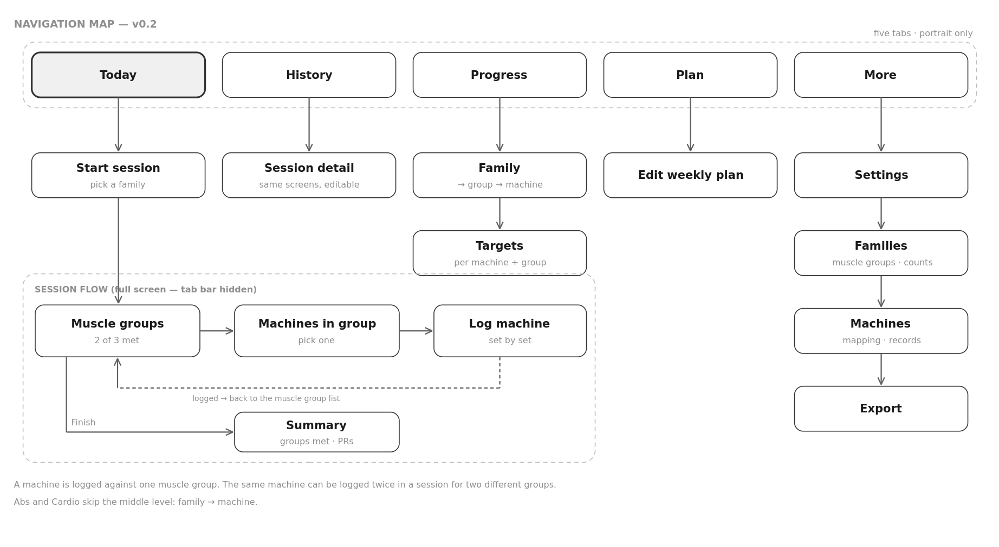
Navigation map. The session flow is three levels deep and returns to the muscle group list after every machine.
- Today — what is due, one tap to start it, this week at a glance.
- History — every session, by date, editable, showing which groups were met.
- Progress — browse family, then muscle group, then machine; charts and targets.
- Plan — weekly targets per family. The replacement for the todo tab.
- More — the taxonomy editors, settings and export.

7. Data model
Nine entities. The shape matters more than the technology: it is what makes the completion rule, the multi-group machines and editable history possible, and it is the expensive part to change later.
Entity | Fields | Notes
Family | id · name · position · shows muscle groups (yes/no) | Push, Pull, Legs, Abs, Cardio. Abs and Cardio hide the middle level.
MuscleGroup | id · name · position · archived | A managed list, not free text: chest, shoulders, triceps, back, biceps, forearms, quads, hamstrings, calves, hips. Renaming one changes it everywhere.
FamilyMuscleGroup | family · muscle group · position · required machine count | Which groups make up a family, and how many machines each needs. The count lives here, so the same group can require different amounts in different families.
Machine | id · name · aliases · records (reps+weight | duration) · weight increment · default rest · notes · archived | One row per physical machine. The Smith machine is one machine, not three.
MachineMuscleGroup | machine · muscle group · variant name | Many-to-many, and may cross families. "Variant" is the optional label for how it is used — incline press, shoulder press, squat.
Session | id · date · family · started · finished · status · notes | One training session, belonging to one family.
SetEntry | id · session · machine · muscle group · set number · reps · weight · duration · completed · skipped · skip reason · note | The atom. It carries both machine and muscle group, which is what makes the same machine countable twice in one session for two groups.
Target | id · machine · muscle group · target weight · target reps · target sets · due date · achieved date | A goal for one machine used for one muscle group. Kept after it is hit.
WeeklyPlan | family · times per week · active from | Dated, so changing the plan does not rewrite last month's adherence.

Four decisions worth naming, because they are hard to reverse:
- The muscle group is on the set, not inferred from the machine. This single field is what removes the need for primary and secondary muscle weighting.
- Weight is stored once, canonically, in one unit and converted for display. Mixing units in storage quietly corrupts a chart two years later.
- "Last time" is keyed on machine and muscle group together. Smith machine for chest and Smith machine for shoulders are different histories with different weights, and showing the wrong one is worse than showing nothing.
- A session records the required counts that applied when it happened. Raising chest from one machine to two in November must not retrospectively fail August.

8. Functional requirements
Priorities: Must (v1 does not ship without it) · Should (v1 is poorer without it) · Could (nice, if cheap) · Later (agreed, but not now). IDs are carried over from v0.1 where the requirement survived.

8.1 A — Taxonomy
ID | Requirement | Priority
A1 | The app ships with the taxonomy seeded from the spreadsheet: five families, the muscle groups in Appendix B, and the 23 machines mapped to them, with spellings corrected and the original names kept as aliases. | Must
A2 | Muscle groups are a managed list. They are chosen from a picker when mapping a machine, never typed free-hand, so the same muscle cannot exist under three spellings. | Must
A3 | Add, rename and archive a machine. Archiving keeps its history; deletion is offered only for machines with no logged sets. | Must
A4 | Each machine carries: name, what it records (reps and weight, or duration), weight increment, default rest, and a free-text note. | Must
A5 | A machine can be mapped to any number of muscle groups, including groups in different families, each with an optional variant label. | Must
A6 | A family is an ordered list of muscle groups, each with its own required machine count. The count is set per muscle group per family. | Must
A7 | A family can be configured to have no muscle groups, in which case its machines are listed directly and the middle level never appears. Abs and Cardio ship this way. | Must
A8 | Families, muscle groups and mappings can all be edited. Changing any of them never alters sessions already logged. | Must
A9 | Machine notes persist across sessions — seat height, pin position, which corner of the gym. | Could
A10 | Additional families beyond the five (upper/lower, a holiday routine). | Could

8.2 B — Logging a session
This is the app. Everything here is worth more than everything after it.
ID | Requirement | Priority
B1 | Start a session for a family in one tap from Today. | Must
B2 | The session screen lists the family's muscle groups with, for each, the number of machines logged against the required count, and the machines already used. | Must
B3 | Tapping a muscle group shows the machines mapped to it, each with what he last did on that machine for that muscle group. | Must
B4 | Sets are recorded individually against a machine and a muscle group: set number, reps, weight (or duration), done. Sets can be added or removed freely. | Must
B5 | The same machine can be logged twice in one session for two different muscle groups, as two independent entries. | Must
B6 | Before any input, the logging screen shows what he did last time on this machine for this muscle group, with the date, and the current target. | Must
B7 | Values pre-fill from the last session so that repeating a set is a single tap. | Must
B8 | Weight and reps adjust with large plus/minus controls stepping by that machine's increment; tapping the number opens a numeric keypad. | Must
B9 | A machine counts toward its muscle group only when at least one set records both reps and weight, or a duration. A machine touched but not recorded does not count. | Must
B10 | A muscle group or a machine can be marked skipped with a reason. A skipped group with a required count above zero fails the session honestly rather than silently. | Must
B11 | Every entry is saved as it is made. A crash, a call or a flat battery loses nothing, and the session resumes where it stopped. | Must
B12 | A session can be logged for a past date, and any historical set edited or deleted. | Must
B13 | A machine not yet mapped to the muscle group can be used mid-session, and the mapping offered as a permanent addition afterwards. | Should
B14 | Implausible values are flagged inline ("408 kg — did you mean 40?") but never rejected. | Should
B15 | A rest timer with a per-machine default starts when a set is logged, runs in the background, and signals when it ends. | Should
B16 | Finishing shows a summary: which groups were met, duration, sets, volume, personal bests, and a note field. | Should
B17 | An optional flat view listing every machine in the session without the muscle group level, for anyone who prefers the way other apps work. | Should
B18 | Optional per-set effort rating (RPE), off by default. | Could
B19 | Supersets, drop sets, tempo and timed holds. | Later

8.3 C — Plan and adherence
ID | Requirement | Priority
C1 | A weekly plan sets a target frequency for each family — push 2, pull 2, legs 2, cardio 3, abs 3, or whatever he decides. | Must
C2 | Today shows what is due, what is outstanding this week, and a one-tap start. | Must
C3 | A session counts toward the weekly target once it is started and has at least one logged machine, whether or not every muscle group succeeded. Success and attendance are two different measures and both are shown. | Must
C4 | A week view showing each day's family and whether the session succeeded. | Should
C5 | An adherence summary: sessions this week against target, and the run of weeks meeting the plan. | Should
C6 | A quick way to log an abs or cardio session with minimal detail, for days when the full flow is more ceremony than the activity deserves. | Should
C7 | Optional reminders on days with something outstanding. Off by default. | Could
C8 | Planned rest days and deload weeks that do not count against adherence. | Could

8.4 D — Targets and personal bests
This section still depends on Q3 and should be rewritten once it is answered.
ID | Requirement | Priority
D1 | A target can be set for a machine used for a muscle group, as weight × reps, with an optional date. | Must
D2 | Progress toward each target shows current best against target, with a state: not started, on track, behind, achieved. | Must
D3 | The active target appears on the logging screen for that machine and muscle group. | Must
D4 | Personal bests are detected automatically per machine and muscle group — heaviest weight, best estimated one-rep max, best volume — and surfaced in the session summary. | Should
D5 | Achieved targets are kept with the date they were hit rather than deleted. | Should
D6 | When a target is hit the app proposes the next one. A suggestion he accepts or ignores; nothing is applied silently. | Should
D7 | Habit targets: sessions per week or month, and streaks. | Could
D8 | Body weight or measurements. | Later — see Q11

8.5 E — Progress and history
ID | Requirement | Priority
E1 | Browse progress down the taxonomy: family, then muscle group, then machine. | Must
E2 | Per machine and muscle group: a chart of top-set weight over time with the target drawn on it. | Must
E3 | Every session browsable by date, newest first, showing which muscle groups were met, filterable by family. | Must
E4 | Sets per muscle group per week, and volume per muscle group. Exact rather than estimated, because every set names its group. | Should
E5 | The chart switches between top-set weight, estimated one-rep max and volume, over one month, three months, six months or all. | Should
E6 | A calendar month view marking the family trained each day and whether the session succeeded. | Should
E7 | A personal-best list across all machines. | Should
E8 | Comparison between two periods. | Could

8.6 F — Data
ID | Requirement | Priority
F1 | All data is stored on the device. Every feature works with no network connection. | Must
F2 | Export everything as CSV (one row per set, carrying machine and muscle group) and as a complete JSON backup, through the iOS share sheet. Ships with M2. | Must
F3 | No account, no sign-up, no third-party analytics, no advertising code. | Must
F4 | Automatic backup to his own iCloud, restoring onto a new or reset device. | Should
F5 | Import of the old spreadsheet. | Dropped
F6 | Completed sessions written to Apple Health. | Later

8.7 G — Settings
ID | Requirement | Priority
G1 | Weight unit — kilograms by default, pounds supported — applied consistently. | Must
G2 | Default rest time and default weight increment, overridable per machine. | Must
G3 | The screen stays awake while a session is in progress. | Must
G4 | Light and dark following the system setting. | Should
G5 | Delete all data, behind a confirmation and an offer to export first. | Should

9. Non-functional requirements
ID | Requirement | Priority
N1 | iPhone and iPad. Portrait only — no landscape layouts anywhere, including iPad. Minimum iOS version to be confirmed (Q15). | Must
N2 | Entirely offline. No feature may depend on connectivity, and no core screen may show a loading state. Several competitors are weak here; it is a differentiator rather than hygiene. | Must
N3 | Cold start to Today in under two seconds on his device. | Must
N4 | Repeating a set: one tap. Changing the weight and logging: no more than three. Reaching a machine from the start of a session: no more than two. | Must
N5 | Touch targets at least 44 × 44 points. Primary actions in the lower third, reachable one-handed. | Must
N6 | Readable at arm's length in bright light: numbers read mid-set at least 15 pt, high contrast. | Must
N7 | No data loss under crash, force-quit or power failure. Writes are committed per set. | Must
N8 | Nothing leaves the device without an explicit action by him. | Must
N9 | Versioned database migrations, so no future release can orphan his history. | Must
N10 | Dynamic Type supported and every control has a VoiceOver label. | Should
N11 | A sixty-minute session with the screen awake should cost under roughly 8% battery on a current iPhone. | Should
N12 | The app must keep working for years with no maintenance: no server, no certificate expiring unexpectedly. See §11. | Must

10. Wireframes
Thirteen screens, portrait, deliberately unstyled. Grey boxes and one typeface, so the review is about what is on the screen and in what order rather than about colour or personality. The numbered markers down the right edge match the notes beside each screen. The content is his own taxonomy, so the screens can be read as if he were mid-way through a push day.

W1 — Today
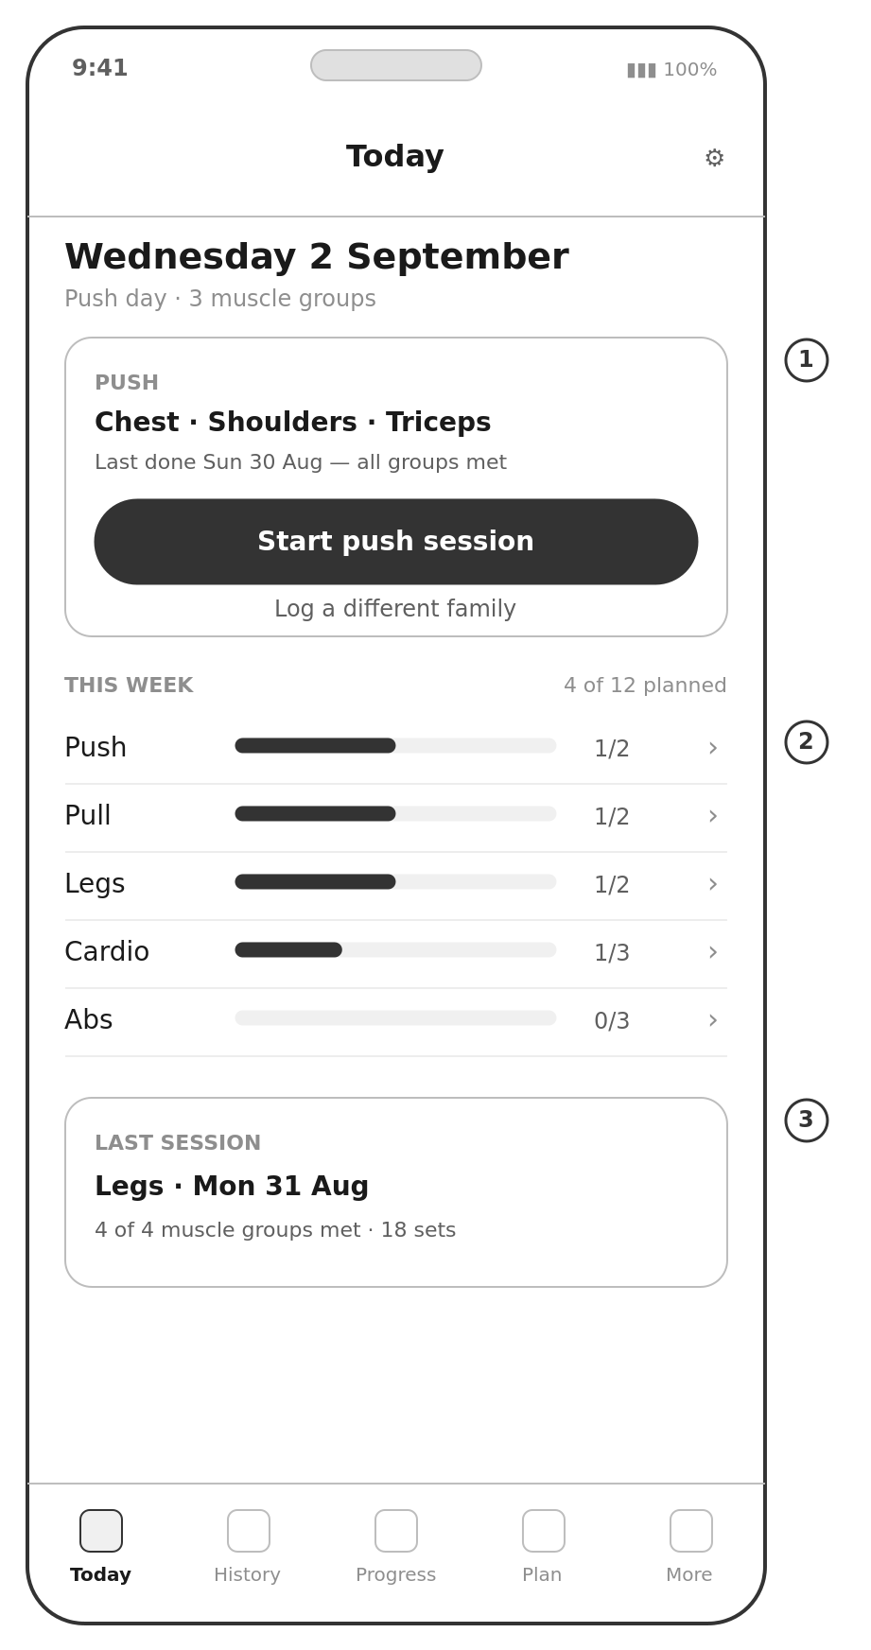 | The screen he opens walking into the gym.  1. One tap to start. The card names the muscle groups rather than the machines, because that is what the session commits him to.  2. All five families, including cardio and abs, now behave the same way. The one-tap tick is gone; each is a real session with machines behind it. Whether that is too much ceremony for abs is C6 and worth his opinion.  3. The last session reports muscle groups met rather than exercises completed.

W2 — Session: muscle groups
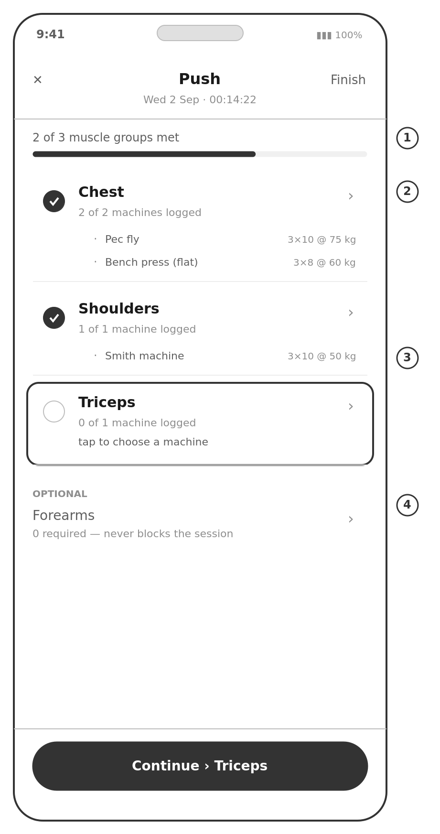 | The spine of a session, and the biggest change from v0.1.  1. Progress is counted in muscle groups, not machines. Two of three, not six of eight.  2. Each group shows the machines already logged against it. Chest required two and got two.  3. An unmet group is highlighted and tappable. There is no fixed list to work through — he chooses the machine when he gets there.  4. A group with a required count of zero sits under Optional. It is visible, it can be trained, and it can never fail the session.

W3 — Machines for a muscle group
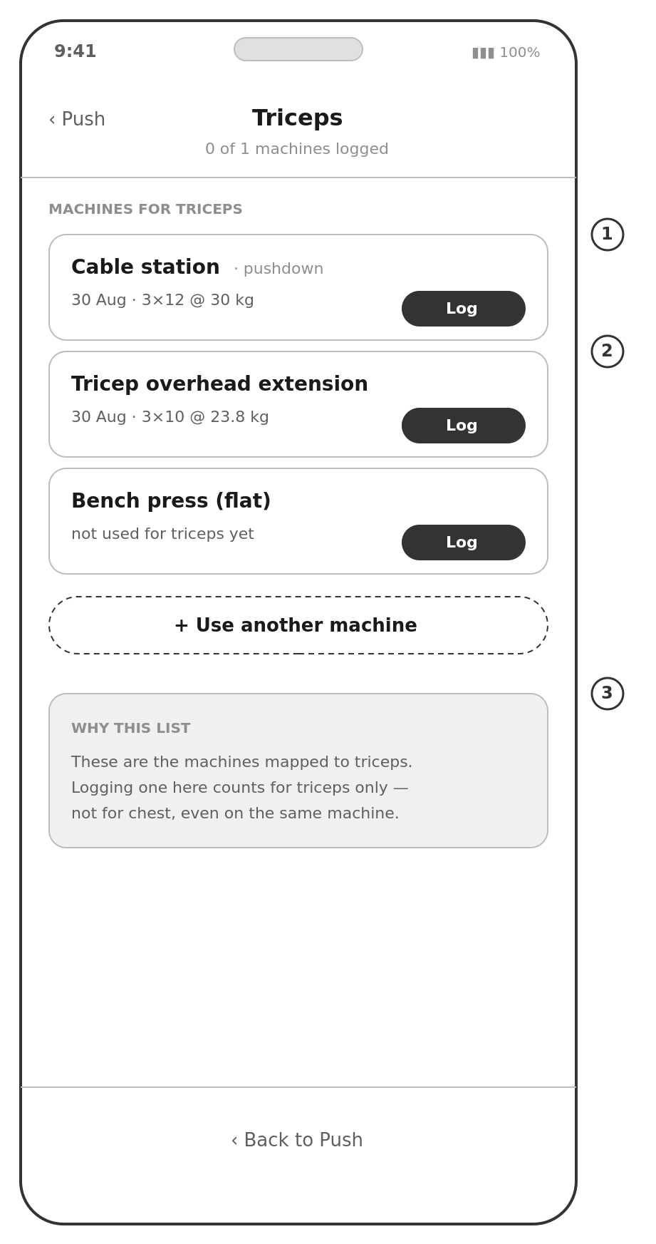 | The screen that makes a busy gym a non-event.  1. Every machine mapped to this muscle group, each showing what he last did on it for this group specifically.  2. If the bench is taken he picks something else and the group is still satisfied. The deviation is not a deviation.  3. Stated plainly on the screen: logging here counts for triceps only. This is the rule most likely to be misread, so it is written down rather than implied.

W4 — Logging a machine
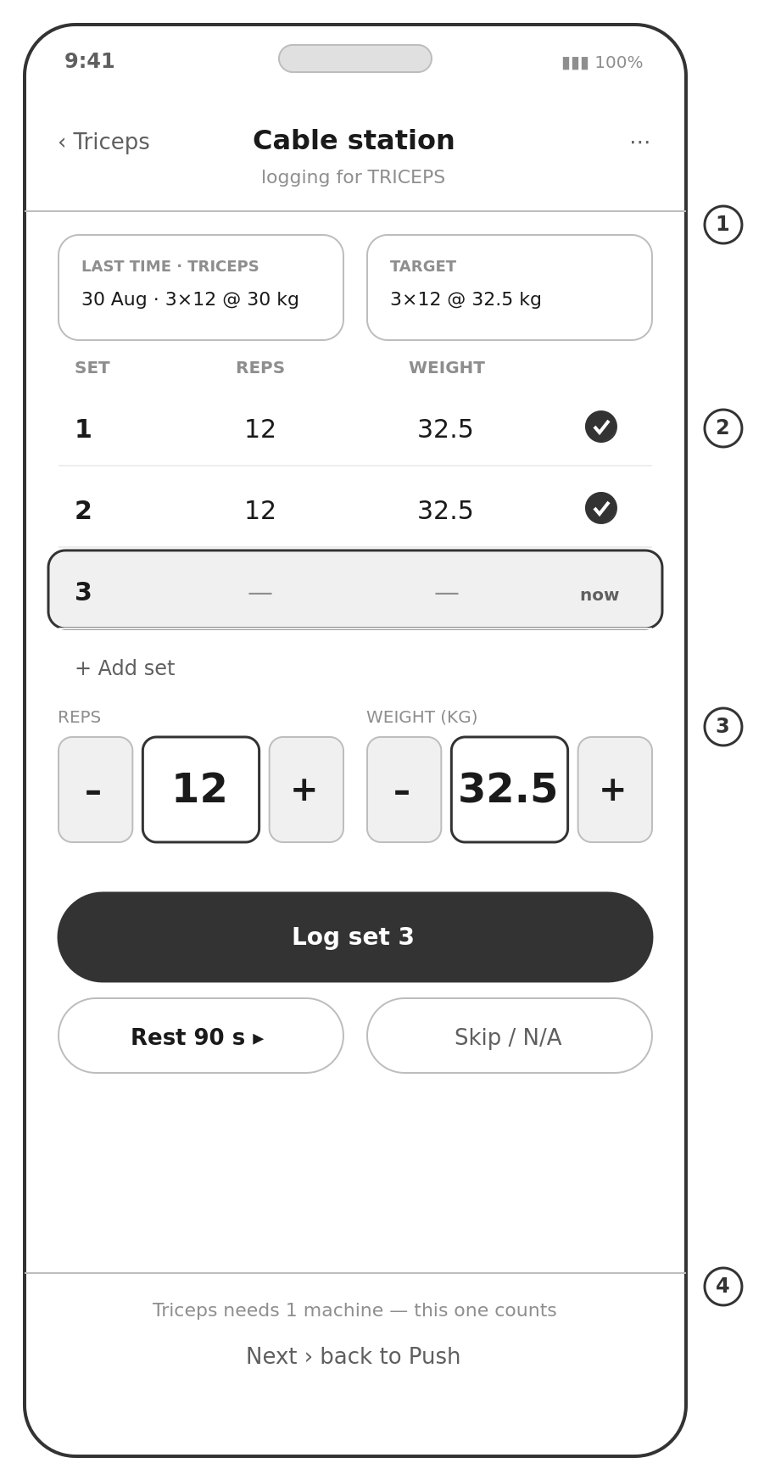 | The screen that has to be excellent.  1. The header names both the machine and the muscle group it is being logged for. "Last time" is keyed on both together.  2. Sets are individual rows. The next set is highlighted and pre-filled from the last one.  3. Large plus/minus controls step by this machine's increment; tapping the number opens a keypad.  4. The footer says what this machine will do for the group's requirement, so the consequence of logging is visible before he taps.

W5 — Session summary
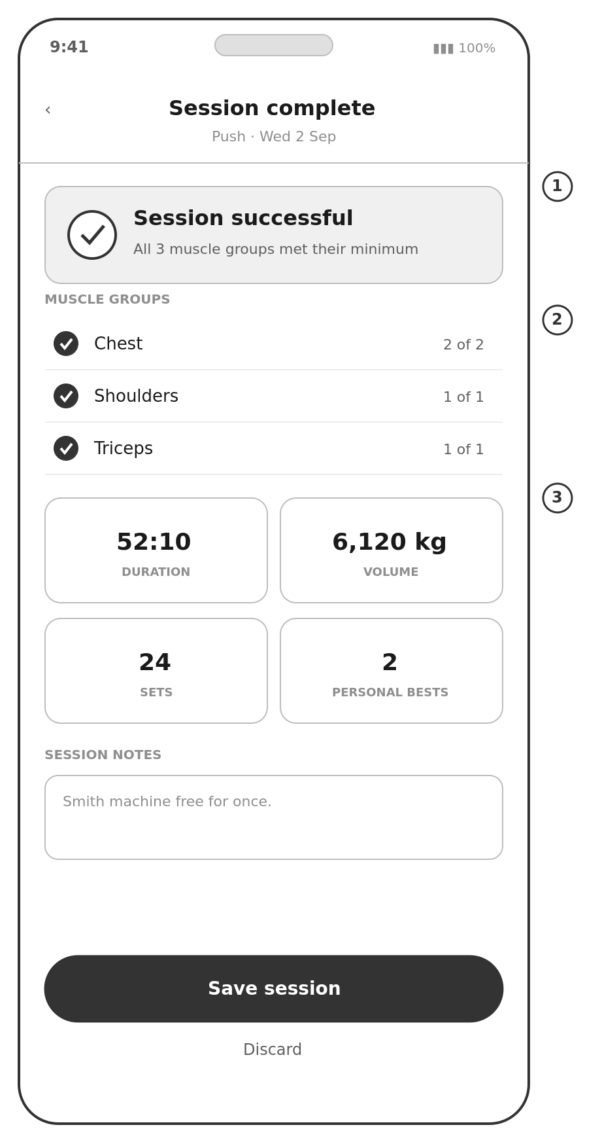 | The payoff, and the thing no other app does.  1. The verdict first. A session succeeded or it did not, and the rule is his own.  2. Then the evidence: every muscle group and how it was met.  3. The numbers underneath. Volume is exact per muscle group because every set names its group.

W6 — Plan
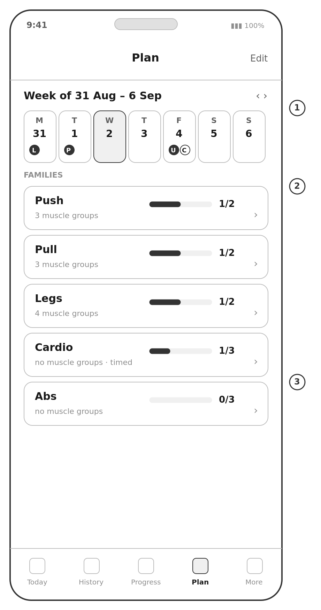 | The replacement for the todo tab.  1. One week rather than a forty-five-row grid, navigable in both directions.  2. Families rather than exercises, with cardio and abs marked as having no muscle groups.  3. Targets are weekly, so a missed Tuesday breaks nothing.

W7 — History
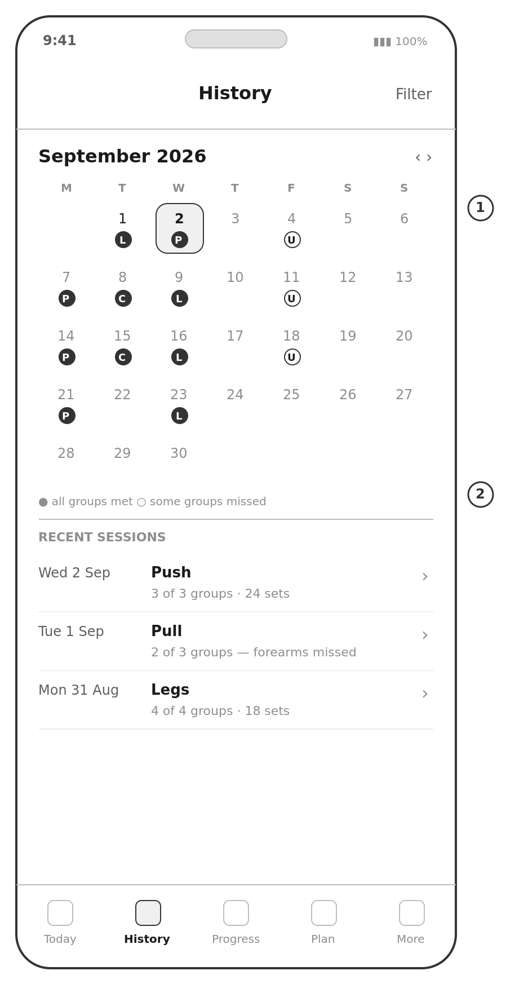 | For the Sunday-evening question.  1. A filled marker means every muscle group was met; a hollow one means some were missed. The spreadsheet could only say yes or no.  2. Any session opens for editing, so a mis-typed 408 kg is fixed in two taps.

W8 — Progress
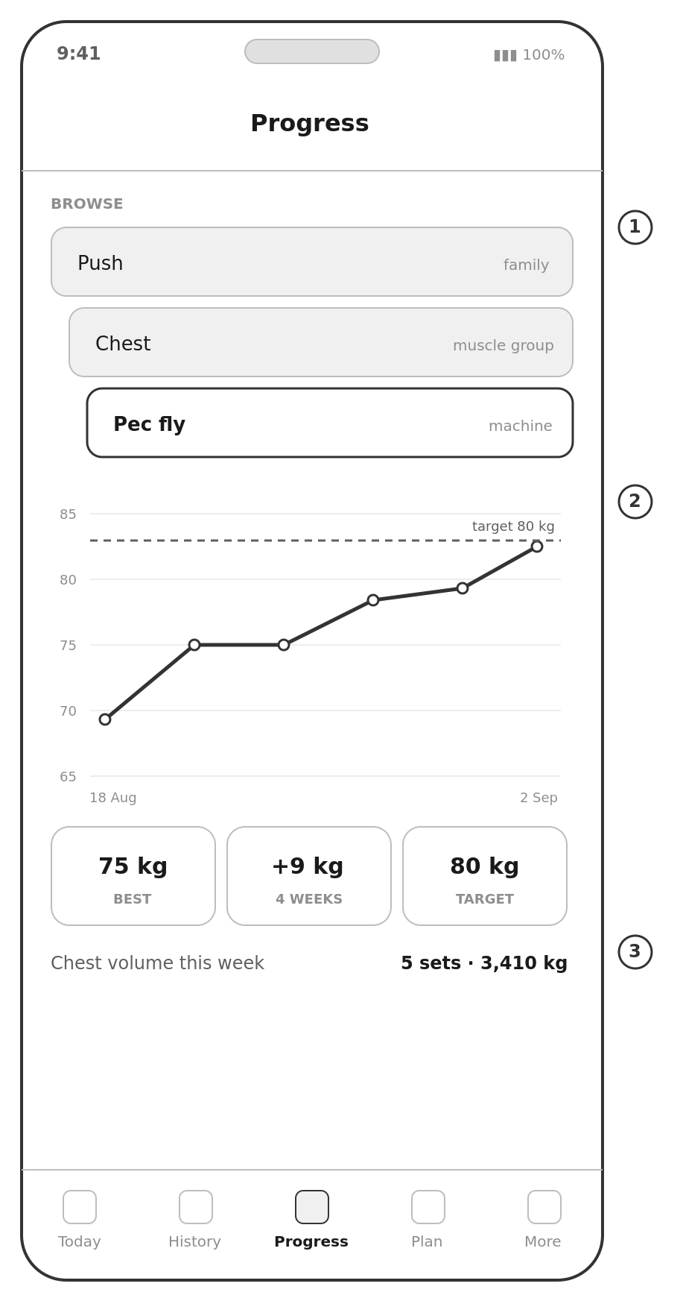 | Browsing down the taxonomy.  1. Family, then muscle group, then machine — the same three levels used everywhere else, so there is nothing new to learn.  2. The chart is per machine per muscle group, with the target drawn on it.  3. Sets and volume per muscle group are exact, not estimated, because he chose the group when he logged.

W9 — Targets
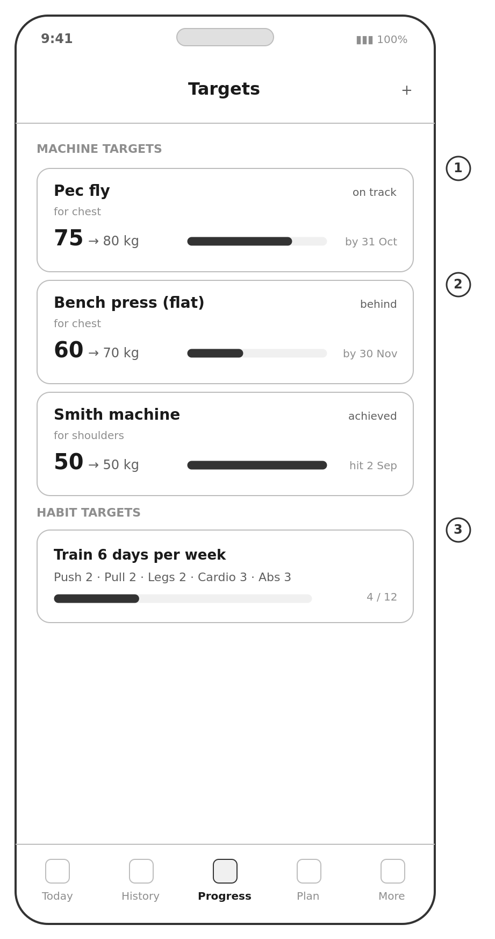 | Still a guess until Q3 is answered.  1. A target belongs to a machine used for a muscle group, not to a machine alone.  2. Status is computed, never set by hand.  3. Habit targets are the weekly plan restated as a goal.

W10 — Family editor
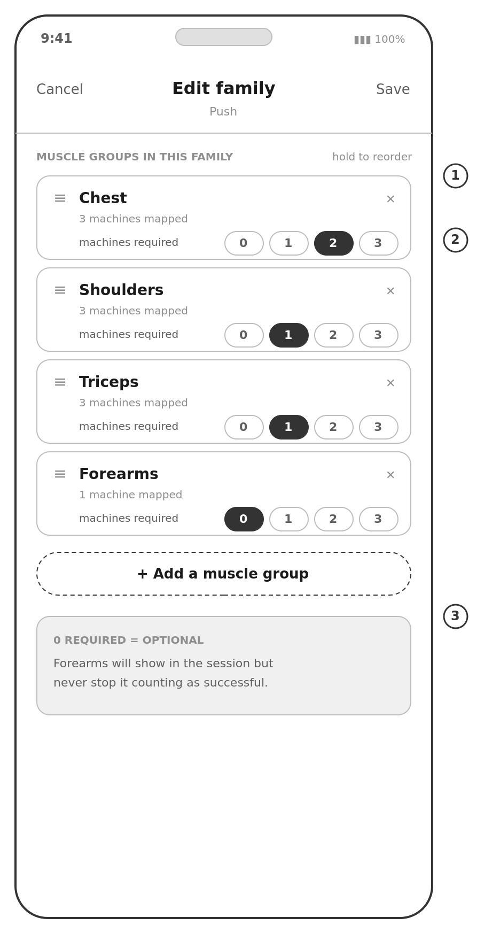 | Where the completion rule is configured.  1. A family is an ordered list of muscle groups.  2. The required machine count is set here, per group within this family — so chest can require two on push day and a different number elsewhere.  3. Zero required is spelled out as optional, because it is the release valve for single-machine groups like forearms.

W11 — Machine editor
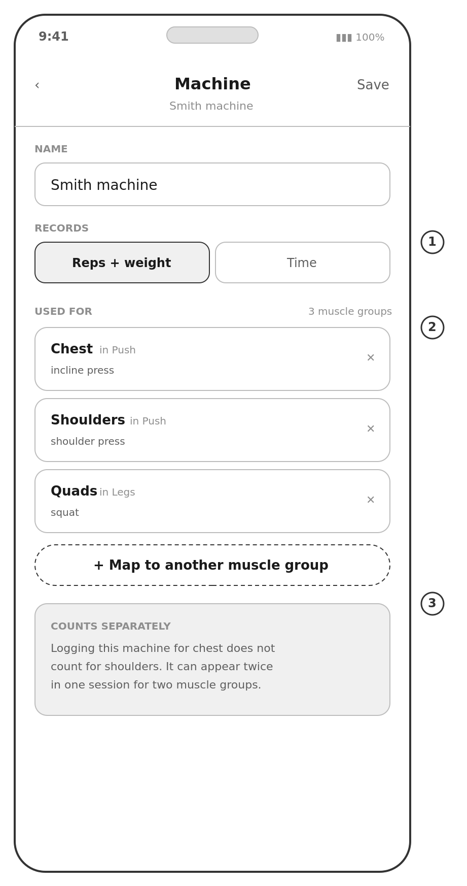 | Where a machine is mapped to what it can be used for.  1. What the machine records — reps and weight, or time — which is how cardio machines fit without a special case.  2. One machine, several muscle groups, across families. The Smith machine is chest and shoulders in push, and quads in legs.  3. The rule restated where it is created: logging for one group does not count for another, and the machine may appear twice in one session.

W12 — Settings
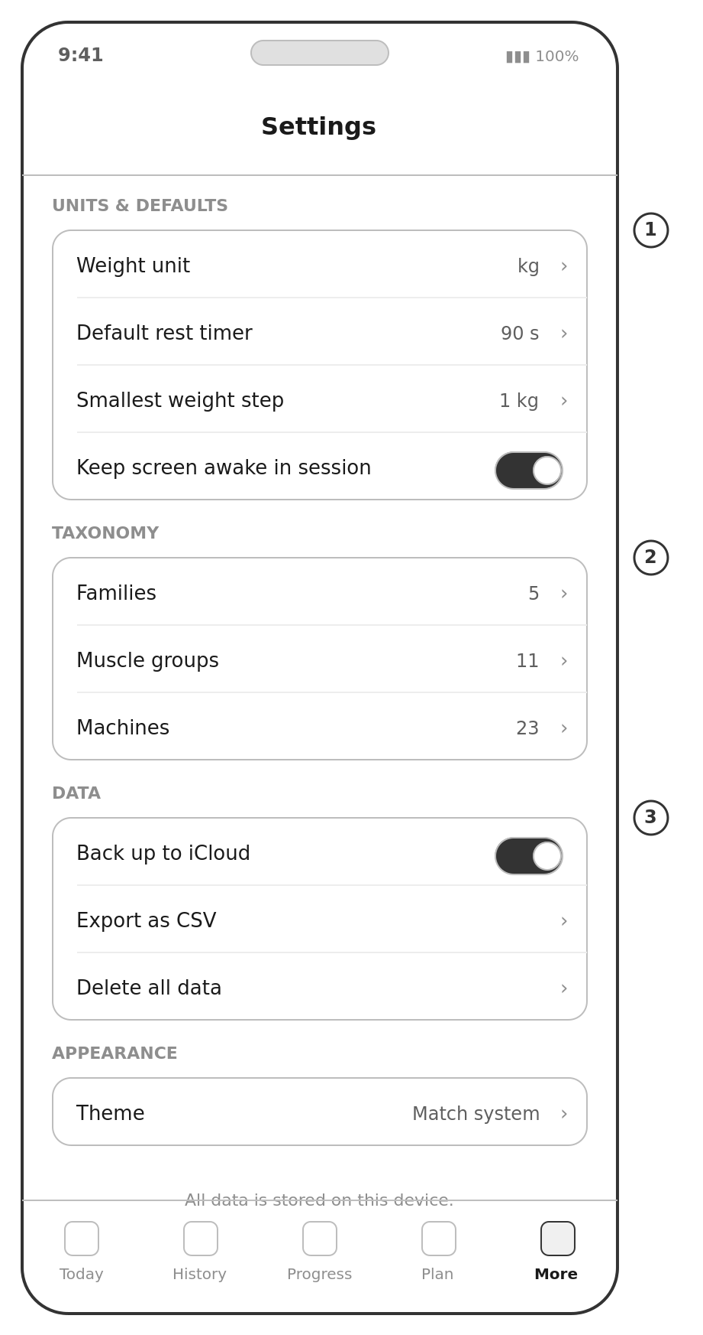 | Short on purpose.  1. Units and increments — the things that vary by gym and machine.  2. The taxonomy is reachable from here as well as from More, since it is the thing most likely to be edited in the first month.  3. Export and delete are first-class. The data is his.

W13 — iPad, portrait
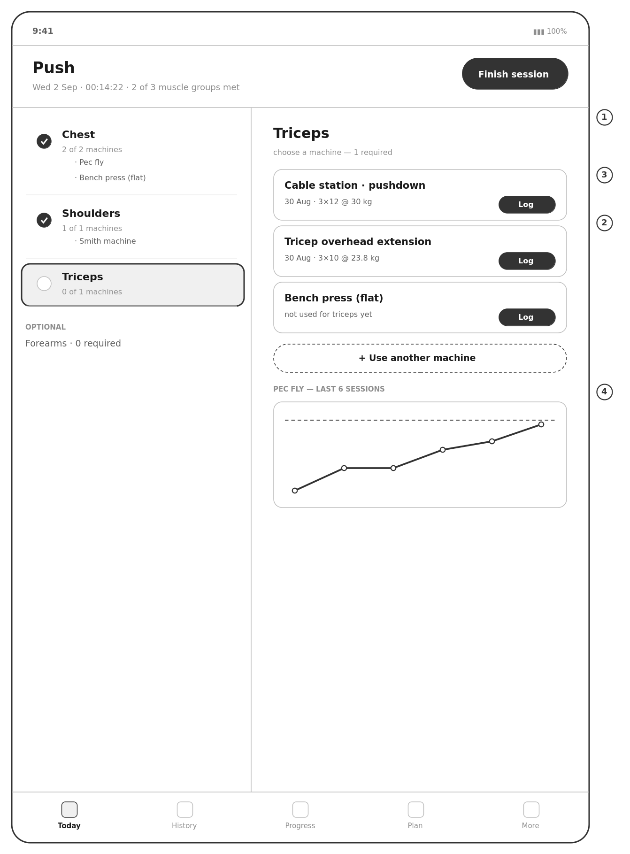
Muscle groups on the left, the chosen group's machines on the right. Portrait only, as agreed.
- 1. Two panes remove a level of navigation: the groups and the machines are visible together.
- 2. Nothing is iPad-only. It is a wider view of the same data with the same code behind it.
- 3. Touch targets stay phone-sized rather than stretching. Bigger buttons are not better buttons.
- 4. The extra width goes to context — the trend chart — rather than more controls.
Worth confirming whether the iPad is used at the gym or only at home (Q14). If it is a sofa device, this can be simplified considerably.

11. How this compares to existing apps
Reviewed during the design of the taxonomy, to find out whether the model was unusual for a good reason or a bad one.

11.1 What everyone else does
Strong, Hevy, StrengthLog, GymBook and the rest share one model: create a routine, start a session, tap in each set. The routine is a flat ordered list of exercises. Muscle groups exist, but as tags on the exercise — Hevy asks for primary and secondary muscle groups when you create one — and those tags feed analytics such as volume charts and heat maps. No mainstream logger makes the muscle group a level of the session itself.
Muscle-group targets do exist, one layer up. Fitbod counts weekly sets per muscle group against personal targets and models recovery per muscle; Renaissance Periodization programmes against volume landmarks of sets per muscle group per week. Both still log exercise-first. This app pushes that accounting down into the session and uses it as the completion rule, which appears to be genuinely novel.

11.2 What that means for us
- The good reason. A common criticism of the incumbents is that tap-based logging assumes the session goes to plan, and real sessions do not — the rack is taken, so every deviation becomes a negotiation with the interface, which is why people abandon trackers after a few weeks. Choosing the muscle group before the machine dissolves that problem rather than managing it.
- The risk. There is no prior art to copy for the session screen, so W2 and W3 are being designed rather than borrowed, and anyone arriving from Strong or Hevy will find them unfamiliar. B17, the optional flat view, is the hedge.
- What we skip. The primary and secondary muscle distinction, and the convention of counting a secondary muscle as half a set, exist because those apps must infer what a set worked. This app is told, so the numbers are exact and the concept is unnecessary.
- What we should steal. A user complaint about one of these apps — that lats and mid-back count as the same muscle — is the argument for letting him define his own muscle groups rather than shipping a fixed list. A2 exists because of it.
- Where we win by default. Offline reliability is a recurring weakness across the category. N2 was written as hygiene and is worth more than that.

12. Technical approach
SwiftUI with SwiftData, iPhone and iPad, portrait only. The app is small, entirely local, and lives or dies on how it feels with one thumb in a noisy room — the case where native wins and cross-platform tooling costs more than it saves. There is no server, no API and no login to build, so most of the usual argument for React Native or Flutter does not apply.
The honest counter-argument: if neither of us knows Swift and one of us knows React well, the learning curve may cost more than the polish is worth. That belongs to whoever writes the code (Q17).
One note on the schema. The many-to-many mapping between machines and muscle groups, and the muscle group carried on every set, are the two things that must be right in the first migration. Everything else can be added later without pain.

12.1 Getting it onto the phone
This quietly decides whether the project survives.
- Free personal provisioning. No cost, but the app stops working after seven days and needs a Mac to reinstall. Fine during the build, unusable for something he relies on.
- Apple Developer Program, about £79 a year. TestFlight builds last 90 days and reinstall in a tap. The realistic answer if the app is meant to last.
- The App Store. Same cost plus review, screenshots, a privacy label and a support commitment. Only if other people will use it (Q13).

12.2 Testing
- Unit tests on the logic that is easy to get subtly wrong: the completion rule with its per-family counts, personal-best detection, volume and sets per muscle group, estimated one-rep max, weekly adherence.
- A specific test that the same machine logged twice in one session for two muscle groups counts once for each and not twice for either. This is the rule most likely to break in a later refactor.
- A written manual test of the session flow before every release, including force-quitting mid-set.
- A gym test: two real sessions with the build before any new feature is added. If it is slower than the spreadsheet, nothing else matters.

13. Delivery plan
Milestones rather than dates. This is an evenings-and-weekends project and a date invented now is fiction. Each milestone is defined by something demonstrable.
 | Milestone | Contains | Done when
M0 | Agree the plan | This document reviewed, Q3 answered, the Appendix B mappings corrected, platform and distribution decided. | Version 1.0 of this document, with §15 empty.
M1 | Taxonomy | Data model, local storage, the five families, muscle groups, 23 machines and their mappings, plus the family and machine editors. | He opens the app and sees his own taxonomy, with the Smith machine under three muscle groups.
M2 | Log a session | The core loop: start a family, pick a group, pick a machine, log sets, completion rule, finish, summary. Plus CSV export. | He logs a real session in the gym and does not need the spreadsheet. This is the milestone that matters.
M3 | Today and Plan | Weekly plan, adherence, streak, quick logging for abs and cardio. | A full week planned and tracked without the spreadsheet.
M4 | Progress | History, three-level browsing, charts, personal bests, targets, sets per muscle group. | He can answer "is the bench going up" in one tap.
M5 | Data and resilience | iCloud backup and restore, edit of any historical entry. | The app is restored onto a wiped device with nothing lost.
M6 | Polish and live | iPad layout, dark mode, accessibility, installed properly, four-week trial. | Four consecutive weeks logged — success criterion S1.

M2 is the point of the project. If we ship M1 and M2 and stop, he has something better than the spreadsheet and the project is a success. Everything after M2 improves something that already works, which is the right order for a project that has to survive school, work and a shortage of weekends.
Dropping the spreadsheet import removed most of what used to be M5. The milestone that replaced it is about resilience instead, which is worth more.

14. Risks
 | Risk | What we do about it
R1 | Scope creep. The app becomes a project rather than a tool and is never finished. | M2 ships first and stands alone. Requirements marked Later stay later.
R2 | The session flow is unfamiliar to anyone who has used Strong or Hevy, and feels like extra steps. | B17 offers a flat view. Test it in the gym at M2 and count the taps against N4.
R3 | Single-machine muscle groups make sessions fail for the wrong reason — forearms failed all three pull sessions in the historical data. | Required counts are configurable and zero means optional. He sets the defaults himself at M1, with the historical scoring in front of him.
R4 | The opposite failure: counts set so low that every session passes and the score stops meaning anything. | The summary reports groups met rather than a single verdict, so a thin pass still looks thin.
R5 | The taxonomy becomes a chore to maintain — too many muscle groups, too many mappings. | Seeded complete at M1 from the spreadsheet, and machines only need mapping once. Adding a mapping mid-session (B13) means it never blocks training.
R6 | He specified it, we built it, and it never feels like his. | He owns the taxonomy, the required counts and the open questions. Consider him building a screen.
R7 | Distribution friction: the app expires, needs a Mac, and dad becomes tech support. | Decide Q16 early and pay before M2 so the whole build is tested through the real install path.
R8 | Data lost in a later rewrite or migration. | CSV export ships with M2, not M5. Versioned migrations from the first release (N9).
R9 | Time. Both of us have other things to do. | Small milestones, each independently useful. Nothing here needs a free weekend.

15. Open questions

15.1 Answered since v0.1
 | Question | Answer
Q1 | Per-set logging, or one number per machine? | Per set. The data model and W4 are built on it.
Q2 | Where does the required machine count live? | Per muscle group and per family.
Q10 | Cardio in detail, or just a tick? | A family of machines with no muscle groups, recording time rather than weight.
Q12 | Import the eleven old sessions, or start clean? | Start clean. F5 dropped, along with the import wireframe and its appendix.
Q5 | What did "N/A" and "Done" mean? | Mostly that he was logging from memory later. Under B9 a machine without numbers does not count, which is the correct treatment.
— | Should abs have muscle groups? | No. Abs and cardio both go family → machine.
— | Primary and secondary muscles? | Not needed. The muscle group is chosen at logging time, so it is recorded rather than inferred.

15.2 Still open
Blocking
 | Question | Why it matters | Answer
Q3 | What do you mean by targets and goals? A weight on a machine by a date? Sessions per week? Sets per muscle group? Something else? | §8.4 and W9 are a guess. It is the last thing that changes the shape of anything.
Q16 | How should the app get onto the phone — free reinstall every seven days, a paid developer account with TestFlight, or the App Store? | Changes how we test and whether there is an annual cost. Needed before M2.

Taxonomy — needed at M1
 | Question | Why it matters | Answer
Q25 | Are the muscle group assignments in Appendix B right? Particularly: rear delt row under shoulders, hammer curl under biceps and forearms, and whether hips should split into abduction and adduction. | Only he knows how his gym's machines feel. Everything downstream depends on it.
Q26 | Which machines besides the Smith machine and the cable station serve more than one muscle group? | The mapping is where the model earns its keep, and it is cheap to get right now.
Q27 | What required count should each muscle group have? Default is one everywhere; forearms may want zero. | This is the completion rule. Set it with the §3.4 scoring in front of you.
Q28 | What machines belong under Abs and Cardio? The spreadsheet has none. | Both families are currently empty.
Q6 | The legs sheet had an unnamed seventh exercise, used 21 and 31 August (30 reps @ 27.5 kg, then 10 @ 25 kg). What is it? | It should be a named machine in the library.
Q7 | Hack squat showed a weight of 0. Bodyweight only, or is the sled not counted? | Decides whether some machines need a reps-only recording mode.

Detail
 | Question | Why it matters | Answer
Q4 | Is everything in kilograms? Where do the decimals come from — 31.8, 47.3, 68.3? | Decides units, rounding and step sizes.
Q9 | How many times a week for each of push, pull, legs, cardio and abs? | Seeds the weekly plan.
Q29 | Should cardio record distance as well as time? | Time alone keeps the model to two recording types.
Q30 | Is a full session too much ceremony for abs, given it used to be one tick? C6 offers a quick log. | Decides whether the quick path is built at M3 or never.
Q11 | Do you want to track body weight or measurements at all? | Left out of v1 deliberately. Worth a conversation rather than a default.
Q20 | Rest by feel or by the clock? If the clock, how long? | Decides whether the rest timer is a headline feature or a setting.
Q21 | Warm-up sets — recorded separately from working sets? | Affects volume and personal bests.
Q13 | Only ever for you, or might a friend want it? | Anyone else means the App Store, a privacy policy and support.
Q14 | Do you use an iPad at the gym, or only at home? | Decides how much W13 is worth.
Q15 | Which iPhone and which iOS version? | Sets the minimum target.
Q17 | Do you want to write any of it, or spec it and use it? | Changes the plan, the language choice and the timeline.
Q18 | When would you like to be using it? | Decides how much goes into version 1.
Q19 | Streaks and personal-best celebrations: motivating or annoying? | Some people find them a reason to train; some find them pressure.
Q23 | Any training apps you have tried? What made you stop? | Cheapest research available.
Q24 | Worth recording machine settings — seat height, pin position? | Small feature, disproportionately useful in a busy gym.

Appendix A — What is in the spreadsheet
File | gym progression.xlsx — kept as the source of the library, not imported
Tabs | todo · push · pull · legs · Sheet6 (empty)
Calendar range | 15 August – 28 September 2026 (45 days, fixed by hand)
Named exercises | 23 (8 push, 9 pull, 6 legs) plus one unnamed pair of columns on legs
Sessions with data | 11 — push 18, 20, 22, 30 Aug · pull 19, 23, 29 Aug · legs 17, 21, 31 Aug, plus a stray mark on 16 Sep
Complete under the spreadsheet's own rule | 5 of 11
Complete under the new rule (count of one) | 5 of 11 — a different five. See §3.4
Data per exercise per session | One rep figure, one weight figure
Charts, validation, conditional formatting | None
Cells with text where a number was expected | 6

Appendix B — Proposed taxonomy
The seed data for M1, and the thing most in need of his correction (Q25, Q26). Original spellings are kept as aliases so search still finds them.
Family | Muscle group | Machines | Notes
Push | Chest | Pec fly · Bench press (flat) · Smith machine (incline press) | "peck fly" and "SM incline bench press" in the sheet
Push | Shoulders | Lateral raise · Smith machine (shoulder press) · Rear delt row | Rear delt row sits in his push day — confirm the group
Push | Triceps | Cable station (pushdown) · Tricep overhead extension · Bench press (flat) | "trycept" in the sheet
Pull | Back | Lat pulldown · Cable station (pull-up) · Seated row (horizontal) · Seated row (vertical) · T-bar row
Pull | Biceps | Machine preacher curl · Incline bench bicep curl · Hammer curl | "bycept" in the sheet
Pull | Forearms | Cable station (forearm curl) · Hammer curl | One machine in the sheet; a second mapping is proposed — see §3.4
Legs | Quads | Hack squat · Quad extension · Smith machine (squat) | "hax squat", "quad extention"
Legs | Hamstrings | Hamstring curl | Single machine — consider a required count of zero or a second machine
Legs | Calves | Calf raise | "calve rases"
Legs | Hips | Hip abduction · Hip adduction | Should this be two groups rather than one?
Abs | — none — | To be decided (Q28) | No muscle group level
Cardio | — none — | To be decided (Q28) — records time | No muscle group level

Machines serving more than one muscle group, in this proposal: the Smith machine (chest and shoulders in push, quads in legs), the cable station (triceps in push, back and forearms in pull), the bench press (chest and triceps) and the hammer curl (biceps and forearms). Each use counts only for the group it is logged against.

End of document. Version 0.2 — the taxonomy and completion rule are agreed; §15.2 is not.

